Nama : Dwi Satria Indriawan

NIM : 18090146

Kelas : 5B

PRAKTIKUM 2

1. Source Code

latihan1-> application/controller

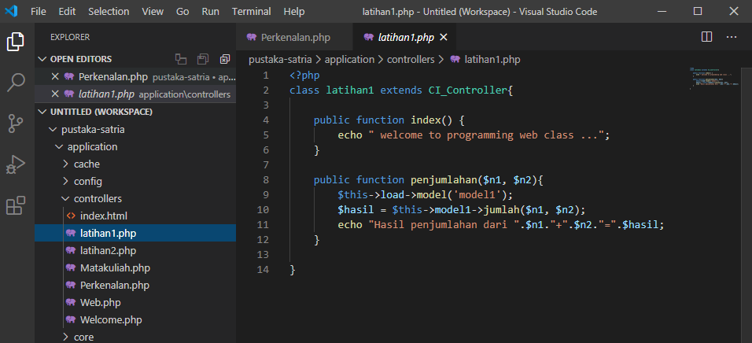

latihan2 -> application/controller

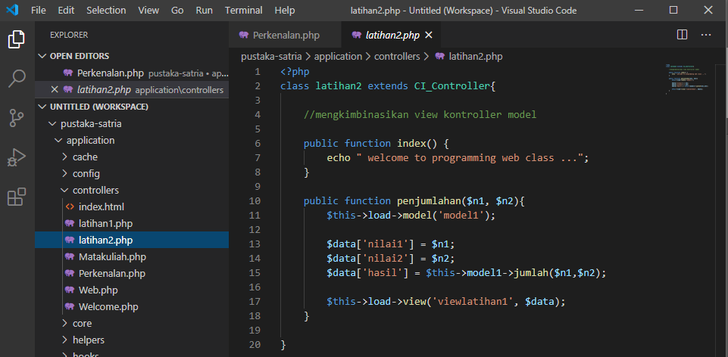

model1 -> application/model

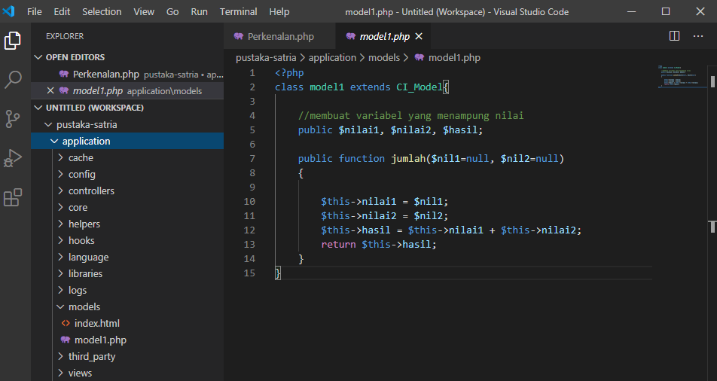

viewlatihan1.php->application/view

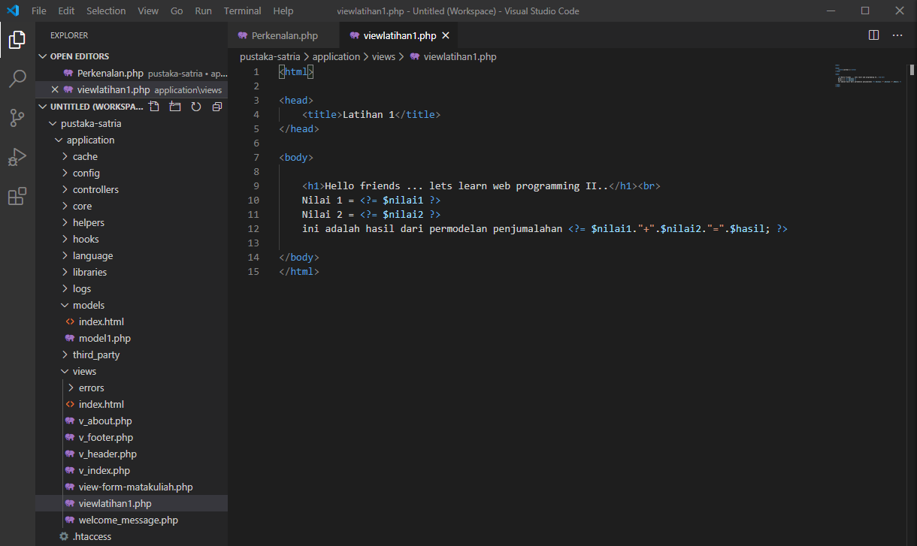

1. URL

<http://localhost/pustaka-satria/index.php/latihan2>

<http://localhost/pustaka-satria/index.php/latihan2/penjumlahan/1/3>

[http://localhost/ pustaka-satria/index.php/latihan1/penjumlahan/4/5](http://localhost/%20pustaka-satria/index.php/latihan1/penjumlahan/4/5)

1. Capture Hasil

**Hasil run latihan 2**

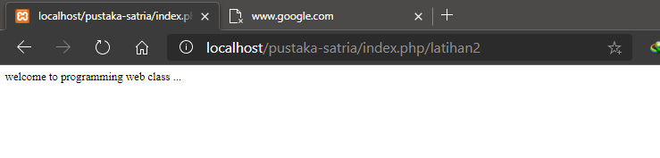

**Hasil run penjumlahan**

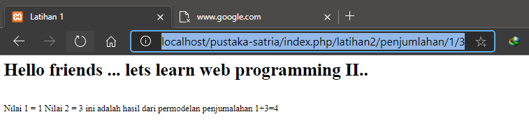

**Hasil run latihan 1**

